Dear Data 100 Project
This is the start of my Dear Data 100 project/assignment. I need to collect 100 data points on a unique topic, record them and then make a sketch of them in processing to display it, aka data visualisation.
So, off we go –

1 – My idea
During the lecture where we were introduced to this assignment, we were told to create a processing sketch of a data set which we have collected over time which holds data/a topic that is interesting, unique and creative. Instantly, the first thing which popped into mind was how angry I get at playing games, specifically a 5v5 shooter called “Valorant”. Firstly, this topic was unique to me, it was interesting as a lot of my friends say I get VERY angry playing this game, so it would help me gain an insight on how angry and frequently I get angry. Lastly, it was quite creative, as getting angry on a video game isn’t a topic a lot of people think about.
Overall, my main question would be “How many times to I get angry during each of my Valorant Sessions”. While that would be the main question, other questions could branch off that, for example:
How long was the game?
Were we winning or losing?
Why did I get angry?
Who was actually at fault?
With my idea generated and finalised, I now needed to do some research and think of how to present my data.

2 – Research
After watching the introduction video and the book’s introduction, we were told to take a look at 3 out of the 52 weeks and study their card, to understand how they were recorded, what is being recorded, how can we discover any patterns, and how can we adapt it to our own data. With my idea in mind, I wanted to look into cards representing emotions and investigate ways to express my idea in a simple way. The three weeks I chose were:
Week 7 – A week of complaints
Week 11 – A week of emotions
Week 35 – A week of getting dressed
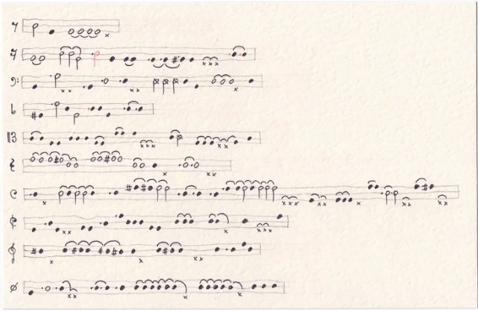
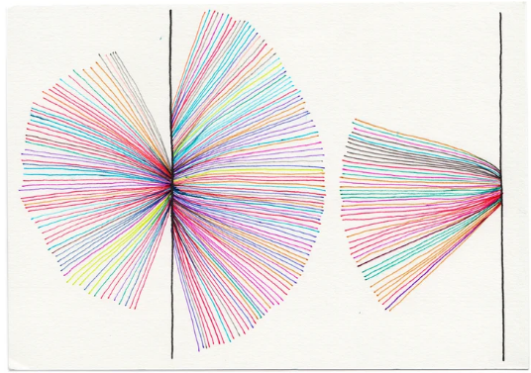
Starting with week 7. This week Giorgia and Stefanie collected data on any dissatisfaction they felt during the week, and who it was from/to, and what it was about. Giorgia presented her data through music notation, while Stefanie did hers through colours, which I find a lot more interesting. Assigning a colour to a certain complaint, then presenting that data in a simple line/star way? I’m not sure how to describe it.
Giorgia’s way of visualizing her data is unique, however a lot more detailed than Stefanie’s. Hers only included what kind of complaint, and who it was directed at. Giorgia’s, one shows that, plus if it was in quick succession, or more detail on who it was to. Giorgia’s one is a lot more presentable, and once understood can be easy to understand, while Stefanie’s one seems like a lot at the start, and can be a lot harder to count and present the data. The reason I chose week 7 here was because of Stefanie, the way of presenting what complaint correlates to what colour can help me possibly categorise why I got angry during my game, and it would make it easier to others to read my eventual data set.
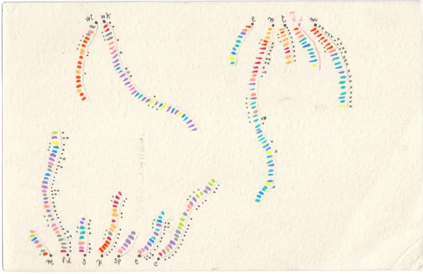
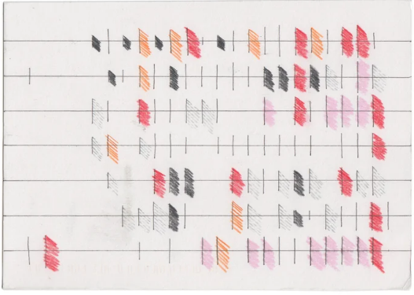
Moving onto week 11, representing emotions they felt during the week. Stefanie presented her with boxes and lines, which is easy to read and understand, while Giorgia has hers representing with colours dashes and squiggly lines.
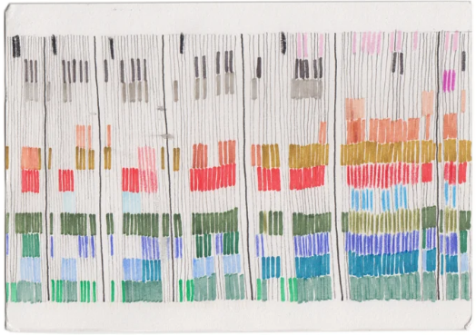
Giorgia’s one is a bit more complicated to understand and read, however it is a lot more detailed than Stefanie, just like week 7. Giorgia has her data easily categorised while Stefanie doesn’t really have specific data, however her’s is easier to understand, and you can clearly see how what she felt at what time during the week. I chose week 11 to try get ideas on how to present my idea, do I put it in a line? Should I box it all up?
Lastly is we have week 35, getting dressed. Stefanie presented her data in a messier way then Giorgia. Hers has a lot more lines and colour, and if a bit harder to understand, while Giorgia one is a lot cleaner and more presentable, and much easier to read and understand.
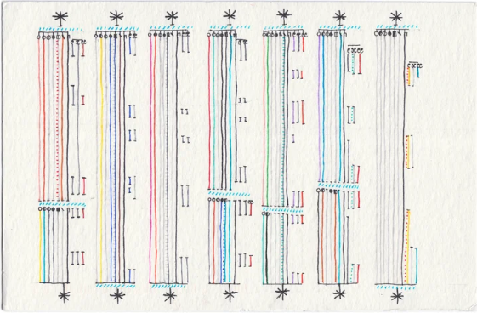
The reason I chose week 35 was because it looked like a good way for me to present my data. Both examples express them in more of a rectangular way, which could be adapted to my one. I could box up each game I play, and in each box, record how many times I got angry while playing.

3 – Structure
After reading the “To draw is to remember” part of the book, it gave me a very good idea on how to record, collect and represent my data.
Essentially, I would need to break down my main question into a lot of other questions, just like I said in the first section. Then during my game I would need to record my data. One way I could to this is with the help of my laptop. Essentially, while I’m playing Valorant, if I get angry, I can move to my laptop and record when I got angry. If I have enough time, I can record why I got angry as well, but I do have a software which records my games, so I can always reference that.
After that, I would start finding patterns and then start rough sketches of visualising my data, then move to the final sketch and then create the instructions to read my data.

